Question 7:
Company database,
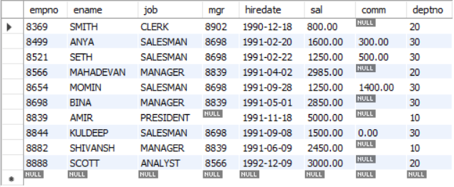
A. Write a query to display EName and Sal of employees whose salary are greater than or
equal to 2200?
SELECT ename, sal
FROM employee
WHERE sal >= 2200;
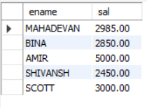
B. Write a query to display details of employees who are not getting commission?
SELECT *
FROM employee
WHERE comm IS NULL;
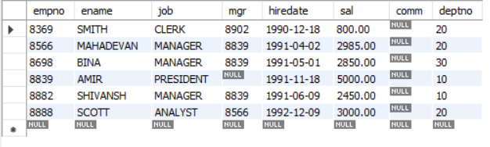
C. Display employee name and salary of employees whose salary is NOT in the range 2500 to 4000
SELECT ename, sal
FROM employee
WHERE sal NOT BETWEEN 2500 AND 4000;
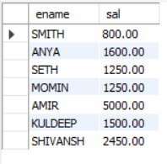
D. Display name, job title, and salary of employees who don't have a manager
(Manager is NULL)
SELECT ename, job, sal
FROM employee
WHERE mgr IS NULL;
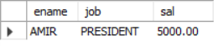
E. Display the name of employees whose name contains "A" as the third alphabet
SELECT ename
FROM employee
WHERE ename LIKE '__A%';
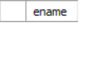 (no employee has letter ‘A’ as the third alphabet in their name)
F. Display the name of employees whose name ends with "T"
SELECT ename
FROM employee
WHERE ename LIKE '%T';
